Powerschool Knowledge Article

Created: 4/1/2016



# Quick Reference Guide

In this article, you should be able to know how to forward emails to another email address.

# 

# Forwarding Your Messages to another Email Address

The vacation responder is a standard message that — while active — is sent to anyone (on your contact list) who sends you an email. However, some emails might require an immediate and personal response. In this section, you should be able to know how to configure your email account to forward emails to another email address.

***Note that in Gmail you can only forward emails to confirmed email addresses.***

1. Log in to your Gmail account and click on the Gear Icon (Cogwheel icon) at the upper right part of your email window and select Settings

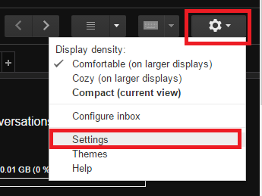

1. Go to the Forward and POP/IMAP tab

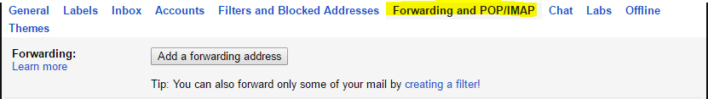

1. Under Forwarding, click on Add a Forwarding Address

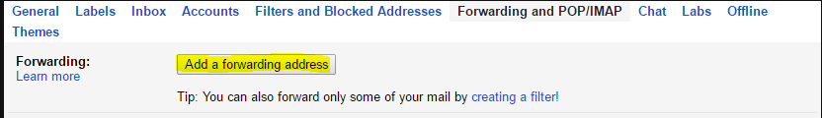

1. Enter the email address where you wanted your emails to be forwarded and click Next to trigger the confirmation email.

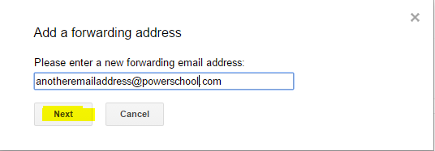

1. Click Save Changes at the bottom of the page.

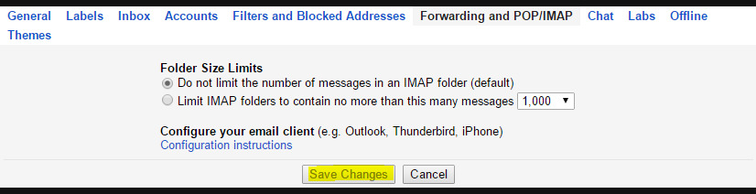

1. The owner of the email address will receive a code and instructions on how to confirm the request.

If they forward you the email, you can also enter the confirmation code yourself to verify their email address.

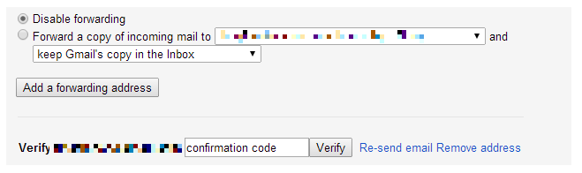

© PureData Inc

www.puredata.io | 5875 N Lincoln Ave, Chicago, IL, 60659